### Employee Data Analysis using Excel

STUDENT NAME: SABITHA P

REGISTER NO: 312208761,641D8B8E359098D8347419E6D26BBCD0 DEPARTMENT: B.COM (GENERAL)

COLLEGE: MEENAKSHI COLLEGE FOR WOMEN

1

2



## PROJECT TITLE

**Quantitative Analysis of Gender Representation in Departmental Staffing**

# AGENDA



1. Problem Statement
2. Project Overview
3. End Users
4. Our Solution and Proposition
5. Dataset Description
6. Modelling Approach
7. Results and Discussion
8. Conclusion

3

3/21/2024 **Annual Review**

## PROBLEM STATEMENT

In contemporary organisational settings, gender diversity and representation are critical factors influencing workplace culture, productivity, and employee satisfaction. Despite increasing awareness and initiatives aimed at achieving gender equity, many organisations still struggle to understand and manage gender distribution effectively across different departments. This gap in understanding can lead to imbalances that impact organisational performance and employee morale.



4



## PROJECT OVERVIEW

#### Evaluate Gender Distribution:

Assess the proportion of female and male employees across departments. **Identify Imbalances:** Determine if certain departments have notable gender imbalances.

**Analyze Trends:** Explore any

trends or patterns in gender representation.

#### Provide Recommendations:

Suggest strategies to address imbalances and enhance diversity.

5

### WHO ARE THE END USERS?

Human Resources (HR) Department Organisational Leadership and Executives Diversity, Equity, and Inclusion (DEI) Teams Department Managers

Employees

6



**OUR SOLUTION AND ITS VALUE PROPOSITION**

#### Comprehensive Gender Representation Analysis:

* + **What:** A detailed quantitative analysis of gender representation across all departments.
  + **How:** Utilising Full-Time Equivalent (FTE) data to assess gender distribution, identify imbalances, and explore trends.

#### Data Visualisation and Reporting:

* + **What:** Clear and accessible visualisations (charts, graphs) and reports summarising findings.
  + **How:** Presenting data in an easy-to-understand format to facilitate interpretation and decision-making.

7

# Dataset Description

The dataset provides comprehensive information on Full- Time Equivalent (FTE) employees by gender across various departments. It includes gender-specific FTE counts and department-level totals, facilitating a detailed analysis of gender representation within the organization. The data structure and quality ensure reliable insights, though limitations such as missing data or lack of granularity should be considered in the analysis.



## THE "WOW" IN OUR SOLUTION

The "WOW" in our solution lies in its ability to deliver profound insights, actionable intelligence, and user- friendly visualisations that drive real change. By providing a comprehensive, transparent, and strategic analysis of gender representation, we enable organisations to make impactful decisions that enhance diversity and foster an inclusive workplace culture.

9

3/21/2024 **Annual Review**

# MODELLING

Our modelling approach encompasses descriptive, comparative, trend, predictive, and scenario analyses to offer a comprehensive understanding of gender representation across departments. By leveraging advanced tools and techniques, we ensure accurate and actionable insights that drive strategic decision-making and foster a more balanced and inclusive workplace.

10

# RESULTS

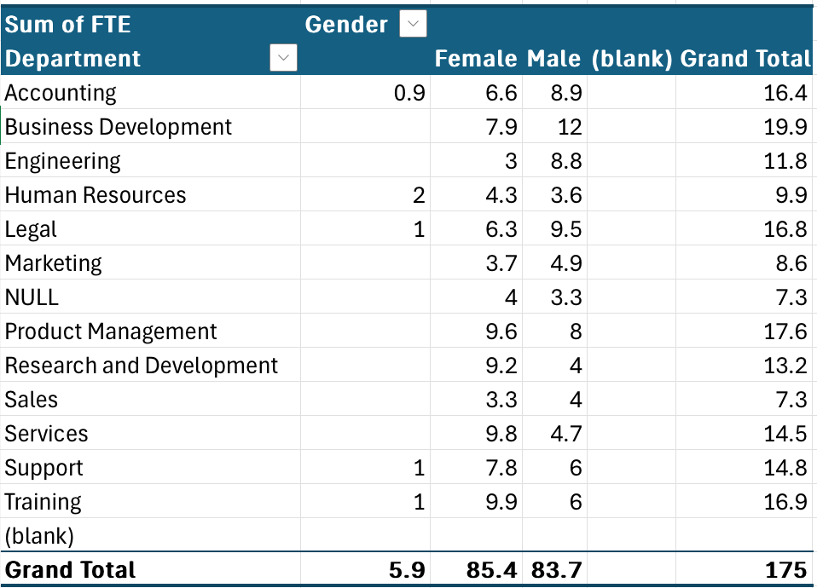

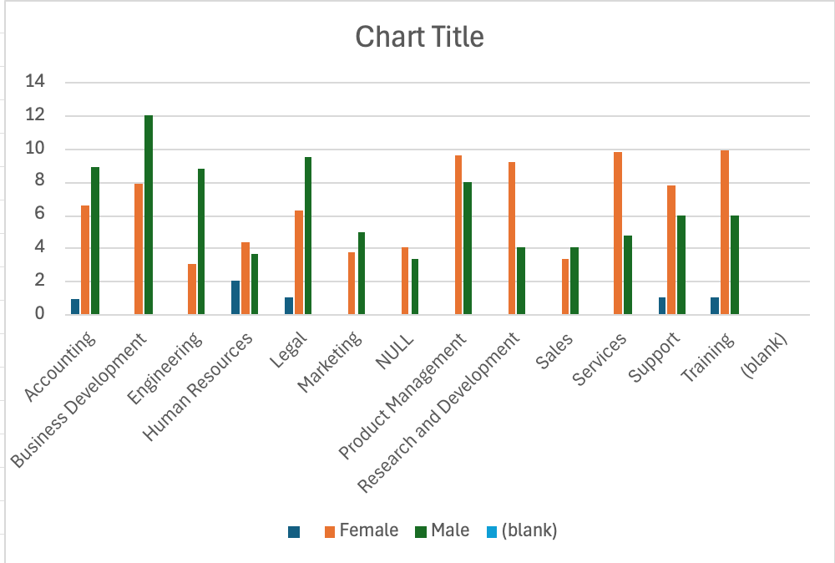

11

# conclusion

The quantitative analysis of gender representation has shed light on key areas of imbalance and provided actionable recommendations for improvement. By leveraging these insights, the organisation can enhance its diversity and inclusion efforts, ensuring a more balanced and inclusive workplace. The next steps involve implementing recommendations, monitoring progress, and engaging stakeholders to drive meaningful change and achieve long-term diversity goals.